39.39: a) The first dark band is located by 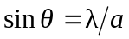
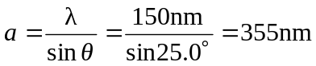
b) Find for the electrons
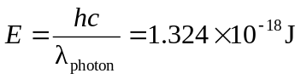
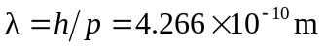
No electrons at locations of minima in the diffraction pattern. The angular position of these minima are given by:

